BCA-103


Storage Classes

Variables are nothing but a fixed number of locations reserved under a specific name. The mode in which a variable is assigned memory space is determined by its storage class. To fully define a variable, we need to mention not only its type but also its storage class. In other words, not only do all variables have a data type, they also have a storage class. The computer allows access to two types of locations:

- Memory

- CPU

If we don’t specify the storage class of a variable in its declaration, the compiler will assume a storage class depending on the context in which the variable is used. Thus, variables have certain default storage classes

Besides the location of the stored variable, a storage class determines:

- Where the variable would be stored. i.e. which memory would be utilized by variable

- What will be the default initial value of the variable, if initial value is not specifically assigned (i.e. the default initial value)

- What is the scope of the variable; i.e. in which functions the value of the variable would be available.

- What is the life of the variable; i.e. how long would the variable exist.

There are following types of storage classes which can be used with a variable

- Automatic storage class

- Register storage class

- Static storage class

- External storage class

The features of all the storage classes have been given in the following table:-

Automatic Storage Classes

The features of a variable defined to have an automatic storage class are as under:

Storage : Memory

Default initial value : An unpredictable value, which is often called a garbage value.

Scope : Local to the block in which the variable is defined.

Life : Till the control remains within the block in which the variable is defined.

Following program shows how an automatic storage class variable is declared, and the fact that if the variable is not initialized it contains a garbage value. Note that the keyword for this storage class is

Storage Classes

BCA-103

auto, and not automatic. All the local variables have the automatic storage class as default storage class.
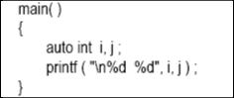

The output of the above program could be...

1211 221

Where, 1211 and 221 are garbage values of i and j.

Register Storage Classes

The features of a variable defined to be of register storage class are as under:

Storage CPU registers.

Default initial value Garbage value.

Scope Local to the block in which the variable is defined.

Life Till the control remains within the block in which the variable is defined.

A value stored in a CPU register can always be accessed faster than the one that is stored in memory. Therefore, if a variable is used at many places in a program it is better to declare its storage class as register. We can name their storage class as register.

Static Storage Classes

The features of a variable defined to have a static storage class are as under:

Storage Memory

Default initial value Zero

Scope Local to the block in which the variable is defined.

Life Value of the variable persists between different function calls.

Compare the two programs and their output given in following code segment to understand the difference between the automatic and static storage classes.

BCA-103

Like auto variables, static variables are also local to the block in which they are declared. The difference between them is that static variables don’t disappear when the function is no longer active. Their values persist. If the control comes back to the same function again the static variables have the same values they had last time around.
In the example, when variable i is auto, each time increment ( ) is called it is re-initialized to one. When the function terminates, i vanishes and its new value of 2 is lost. The result: no matter how many times we call increment ( ), i is initialized to 1 every time.

On the other hand, if i is static, it is initialized to 1 only once. It is never initialized again. During the first call to increment ( ), i is incremented to 2. Because i is static, this value persists.
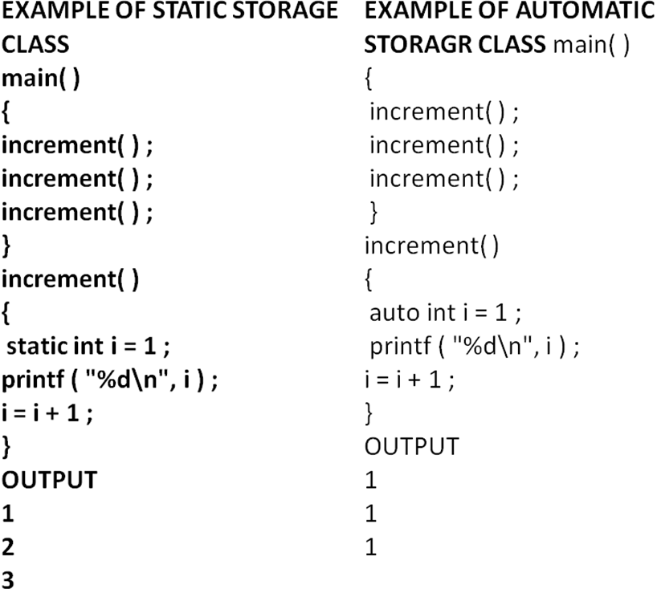

External Storage Classes

The features of a variable whose storage class has been defined as external are as follows:

Storage Memory

Default initial value Zero

Scope Global

Life As long as the program’s execution doesn’t come to an end.

External variables differ from the local variables which have been discussed above in that their scope is global, not local. External variables are declared outside all functions, they are available to all functions that care to use them. Here is an example to illustrate this fact
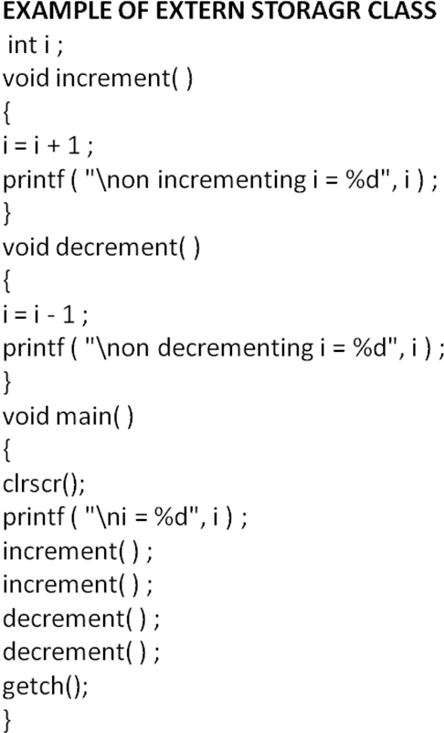

The following table contains the all details in tabulated format about all storage classes

S No | Storage | Location | Default Initial | Scope | Life
S No | Class | Location | Value | Scope | Life
1 | Automatic | Memory | Garbage value | Local to block | Till control is within
 |  |  |  |  | that block
2 | Register | CPU Register | Garbage value | Local to block | Till control is within
 |  |  |  |  | that block
3 | Static | Memory | Zero | Local to block | Persists between
 |  |  |  |  | various function calls
4 | External | Memory | Zero | Global | Till the end of the
 |  |  |  |  | program



Which To Use When

We can make a few ground rules for usage of different storage classes in different programming situations with a view to:

- Economize the memory space consumed by the variables

- Improve the speed of execution of the program

The rules are as under:


Use static storage class only if you want the value of a variable to persist between different function calls.

Use register storage class for only those variables that are being used very often in a program. Reason is, there are very few CPU registers at our disposal and many of them might be busy doing something else. Make careful utilization of the scarce resources. A typical application of register storage class is loop counters, which get used a number of times in a program.

Use extern storage class for only those variables that are being used by almost all the functions in the program. This would avoid unnecessary passing of these variables as arguments when making a function call. Declaring all the variables as extern would amount to a lot of wastage of memory space because these variables would remain active throughout the life of the program.


If you don’t have any of the express needs mentioned above, then use the auto storage class. In fact most of the times we end up using the auto variables, because often it so happens that once we have used the variables in a function we don’t mind losing them.

